Section A:

- Complete this sentence. The reactivity series is a list of…
___________________________________________________________________________
___________________________________________________________________________

- Using the reactivity series, state all the metals that are more reactive than carbon.
___________________________________________________________________________
___________________________________________________________________________

- Write the correct words in the gaps to complete the sentences.

- Oxidation involves reacting with ______________________ to form an oxide.
- An oxidising agent causes the ______________________ of a substance.
- Reduction of a compound involves the loss of ______________________ .
- A reducing agent causes the ______________________ of a substance.

- This question is about a displacement reaction.

- Complete the displacement reaction below.

Zinc oxide + carbon ______________________ + ______________________

- Complete the balanced symbol equation below.

ZnO + C → ____________ + ____________

- Define ‘displacement reaction’.
___________________________________________________________________________
___________________________________________________________________________

- Explain why carbon displaces zinc in this reaction.
___________________________________________________________________________
___________________________________________________________________________

- State what has been reduced in this reaction. Explain your answer.
___________________________________________________________________________
___________________________________________________________________________

Section B

- Choose which metal is found as pure metal in the Earth,
- Tick (✓) one box.
  Sodium | Platinum | Zinc
- Explain your answer to (a).
___________________________________________________________________________

- Rocks can contain metal ores.

- Define ‘ore’.
___________________________________________________________________________

- Explain why aluminium and magnesium are always found as ores in the Earth and not as pure metals.
___________________________________________________________________________
___________________________________________________________________________

- Using the reactivity series, complete the word equations below.

If there is no reaction, write ‘NO REACTION’ and explain why.

- Aluminium oxide + carbon _________________________________________
- Silver oxide + carbon _____________________________________________
- Carbon + magnesium oxide ________________________________________
- Iron oxide + carbon _______________________________________________
- Carbon + sodium oxide ___________________________________________
- Carbon + lead oxide ______________________________________________
- Calcium oxide + calcium __________________________________________

- Complete the table below to state what is being reduced and what is being oxidised in each reaction.

Displacement reaction | What is reduced? | What is oxidised?
Copper oxide + carbon

Lead oxide + carbon

Zinc oxide + carbon

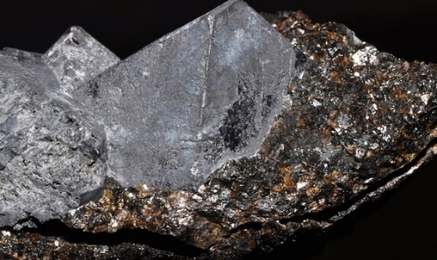
Section C

Galena, shown in the image, is a mineral ore that contains lead sulphide. Galena is the main ore of lead and has been mined for centuries.

Image source: https://commons.wikimedia.org/wiki/File:Galena,_sphalerite.jpg

- Write the compound formula for lead sulphide.
___________________________________________________________________________

- Calculate the relative formula mass of lead sulphide.
___________________________________________________________________________

- Calculate the percentage by mass of lead in lead sulphide.
Give your answer to 1 decimal place.
___________________________________________________________________________
___________________________________________________________________________

- Is lead sulphide an ionic or covalent compound? Explain your answer.
___________________________________________________________________________
___________________________________________________________________________

- Below shows a two-step method for extracting lead from lead sulphide.

Reaction 1 Lead sulphide + oxygen lead oxide + sulphur dioxide

Reaction 2 Lead oxide + carbon lead + carbon dioxide

- Write out the balanced symbol equations for reaction 1 and reaction 2.

Reaction 1 _________________________________________________________________________

Reaction 2 _________________________________________________________________________

- State which reaction shows the oxidation of lead. Reaction _____ .

- State which reaction shows the reduction of lead. Reaction _____ .

- Copper was used instead of carbon in reaction 2. Explain why there was no reaction.
___________________________________________________________________________
___________________________________________________________________________
___________________________________________________________________________

